PREDICTIVE CRIME ANALYTICS FOR SMARTER GOVERNANCE
MACHINE LEARNING & POWER BI DASHBOARD
PROJECT

PROJECT REPORT
BY
SANTHI RP

DATA ANALYST

UNDER THE GUIDANCE & SUPERVISION OF
AMRITHA MR

Palakkad,kerala,678702

CONTENTS

INTRODUCTION
ABSTRACT
OBJECTIVE
METHODOLOGY
DATASET OVERVIEW
DATA ANALYSIS & EDA VISUALS
MODEL DEVELOPMENT & RESULTS
DASHBOARD OERVIEW
CONCLUSION & FUTURE SCOPE

1.INTRODUCTION

With the rapid expansion of digital technologies and internet usage, cybercrime has emerged as a major challenge for governments, organizations, and individuals. Crimes such as online fraud, identity theft, harassment, cyber exploitation, and digital extortion have increased significantly in recent years. Traditional crime analysis methods are often reactive and insufficient to handle the growing volume and complexity of cybercrime data.
Predictive crime analytics leverages data science and machine learning techniques to analyze historical crime data and forecast crime severity across regions. By identifying crime patterns and high-risk areas in advance, authorities can move from reactive policing to proactive governance.
The primary objective of this project is to apply machine learning algorithms to predict crime levels across different cities based on cybercrime data. This predictive approach supports smarter governance by enabling better planning, efficient resource allocation, and enhanced public safety.

2.ABSTRACT

This project focuses on implementing machine learning techniques for predictive crime analytics to support smarter governance. The dataset consists of city-wise cybercrime statistics, including various crime categories such as fraud, extortion, personal revenge, sexual exploitation, causing disrepute, and prank-related offenses.

After performing data cleaning, preprocessing, and exploratory data analysis, crime data was aggregated at the city level. Feature engineering techniques were applied to classify cities into Low, Medium, and High crime levels using quantile-based thresholds.

Multiple machine learning models—Logistic Regression, Decision Tree, Random Forest, K-Nearest Neighbors, and Naive Bayes—were trained and evaluated. Hyperparameter tuning was performed to improve model performance. Among all models, Naive Bayes achieved the highest accuracy, making it the most suitable model for crime level prediction in this study.

3.OBJECTIVES

The main objectives of this project are:
- To analyze city-wise cybercrime data and identify crime patterns
- To perform exploratory data analysis to understand crime distribution.
- To preprocess and engineer features suitable for machine learning models.
- To develop and compare multiple machine learning classification models.
- To identify the best-performing model for crime level prediction.
- To support data-driven decision-making for smarter governance.

4.METHODOLOGY

Step 1: Data Collection
The dataset consists of cybercrime records reported across various cities.
Step 2: Data Preprocessing
Removed duplicate records and inconsistent city names.
Handled missing values and aggregated crime counts at the city level.
Step 3: Exploratory Data Analysis (EDA)
Analyzed crime distribution across cities.
Identified high-crime and low-crime regions using visualizations.
Step 4: Feature Engineering
Created a target variable called Crime Level (Low, Medium, High) using quantile-based classification.
Selected relevant crime-related features for modeling.
Step 5: Model Building and Evaluation
Implemented multiple machine learning algorithms.
Evaluated model performance using accuracy metrics.
Applied hyperparameter tuning using GridSearchCV.

5.DATASET OVERVIEW

Source: Cybercrime dataset
Data Type: City-wise aggregated crime data
Key Features:
Fraud
Extortion
Personal Revenge
Causing Disrepute
Prank
Target Variable: Crime Level (Low, Medium, High)
The dataset was carefully cleaned and standardized to ensure accuracy and consistency before modeling.

6.DATA ANALYSIS & EDA VISUALS

Key Observations:
Certain cities reported significantly higher cybercrime cases than others.
Crime distribution varied widely across regions.
A small number of cities contributed to a large proportion of total crime.
Visualizations Used:
Bar charts showing top high-crime cities.
Bar charts for lowest crime cities.
Comparative plots to analyze crime intensity across regions.
EDA provided critical insights that guided feature engineering and model selection.

7.MODEL DEVELOPMENT & RESULTS

Models Applied:
Logistic Regression
Decision Tree Classifier
Random Forest Classifier
K-Nearest Neighbors (KNN)
Naive Bayes Classifier
Best Model – Naive Bayes
Achieved the highest accuracy after hyperparameter tuning.
Performed well due to its robustness with structured numerical data.
Suitable for datasets with limited features and clear statistical patterns.
The comparison of model performance highlighted the effectiveness of probabilistic models for crime prediction.

8.DASHBOARD OVERVIEW

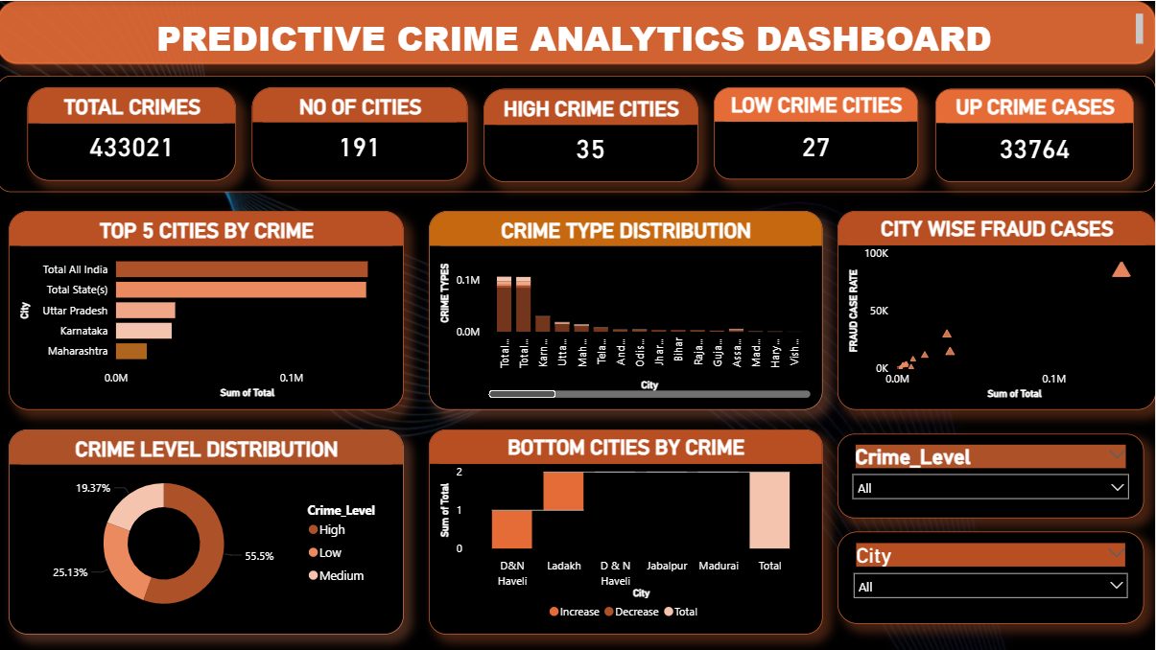

This project focuses on the analysis and visualization of crime data using Predictive Crime Analytics techniques. The main objective of the project is to identify crime patterns, understand city-wise crime distribution, and classify crime levels to support data-driven decision-making. The analysis is implemented using Power BI, which enables interactive dashboards and meaningful visual insights.The dataset used in this project contains city-level crime records with total crime counts and crime categories. During data preparation, the dataset was cleaned and transformed to remove inconsistencies and ensure accuracy. A new calculated column named Crime Level was created to classify cities into High, Medium, and Low crime categories based on predefined thresholds. This classification helps in understanding the intensity of crime across different cities.

The dashboard presents key performance indicators (KPIs) such as:
Total Crime Cases, Number of Cities, High Crime Cities, Low Crime Cities, and Cities with the Highest Crime Rate. Visualizations such as bar charts, donut charts, scatter plots, and waterfall charts are used to show top and bottom cities by crime, crime level distribution, crime type distribution, and city-wise crime trends. Interactive slicers for City and Crime Level allow users to filter data dynamically and explore specific insights

9.CONCLUSION & FUTURE SCOPE

Conclusion

This project successfully demonstrates the application of machine learning techniques in predictive crime analytics. Through data preprocessing, exploratory analysis, feature engineering, and model tuning, crime levels across cities were accurately predicted. Among the evaluated models, Naive Bayes emerged as the best-performing classifier, highlighting its suitability for this dataset. The findings emphasize the importance of data-driven approaches in enhancing public safety and supporting smarter governance.

Future Scope

- Integration of real-time crime data for dynamic prediction.
- Inclusion of demographic and socio-economic factors to improve accuracy.
- Deployment of the model as a web-based or mobile application.
- Application of advanced machine learning and deep learning techniques.
- Use of GIS-based crime mapping for spatial analysis.

